**VPC Peering between Two Different Regions**

**==============================================================================**

**VPC Peering**

VPC peering allow communication between two different VPC which created on different Region by using private IP.

We know generally private ip address can’t communicate with other over the internet, when we create two subnet in same region its ok it will communicate with each other with help of private IP.

But what happen when we create it in different region?

So, on AWS is possible with VPC Peering.

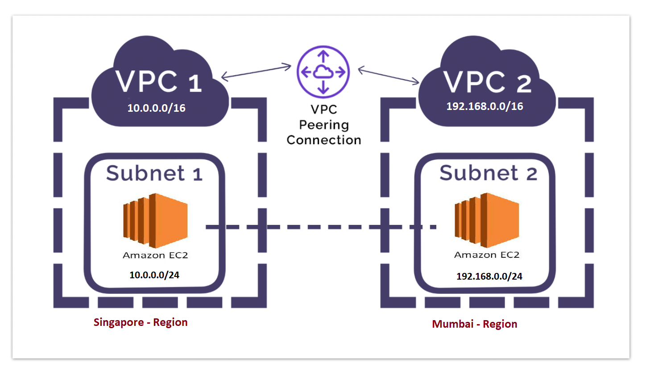

**Transitive peering – Not Allowed**

**==============================================================================**

VPC does not support **edge-to-edge routing**or known as **transitive peering**. That means it cannot go through one VPC to connect to another VPC.

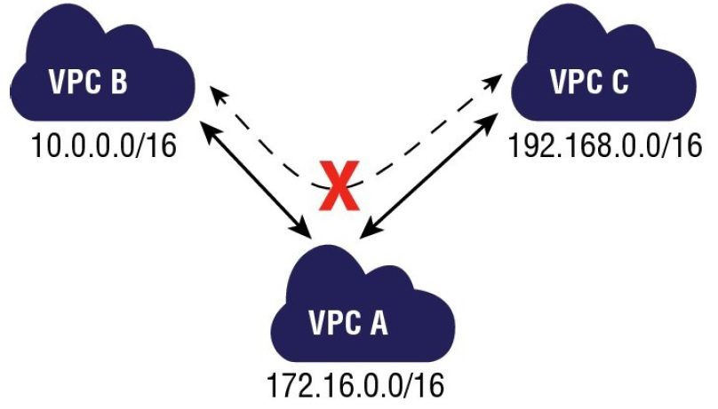

Can’t access from B to C through A. Must create VPC peering from B to C directly

**Lab for Peer VPC created in Different Region:**

Step 1: Create VPC (Singapoor Region)

Service - VPC – your – create vpc – singapoor- VPC (10.0.0.0/16)

**Create Subnet:**

Create Subnet – svpc-subnet 10.0.0.0/24

===============================================================

Step 2: Create Internet Gateway:

Create Internet Gateway – igw-svpc – create - action – attach to vpc – attach.

===============================================================

Step3: Create Routing Table:

Route Table - Create routing table - svpc - routing – vpc ( singappor- VPC ) – route – add internet route 0.0.0..0/0 - select igw – subnet associate – edit – select subnet – save.

Step4: Create security group

Service – EC2 – Security Group - Create new security group – ssecgp (add rule icmp,rdp,ssh)

Step5: Create Instance (linux/windows):

Create EC2 instance – windows server 2019 – allow “All ICMP ipv4” in security group

===================================================================

===================================================================

Now create VPC Mumbai Region

Step 1: Create VPC (Mumbai Region)

VPC – your vpc – create vpc – mumbai- VPC (192.168.0.0/16)

Create Subnet – mvpc-subnet 192.168.0.0/24

Create Internet Gateway – igw-mvpc – creates - action – attach to vpc – attach.

Route Table - Create routing table - mvpc - routing – vpc ( singappor- VPC ) – route – add internet route 0.0.0..0/0 - select igw – subnet associate – edit – select subnet – save.

Create new security group - msecgp

Create EC2 instance – windows server 2019 – allow “All ICMP ipv4” in security group

========================================================================================

Now try to ping between both EC2 Instance using Private IP,Fail to ping in cross region, for connectivity complete peering process.

========================================================================================

Peering process –

-------------------------------

VPC - Peering Connection – create Peering connection – vpc-singapor- Mumbai – VPC (request)- vpc – singapor – Select another VPC to peer with – Region – Another Region – Mumbai(ap-south-1) - VPC (Accepter) < paste here mumbai-vpc ID> - create peering connection- ok.

Now go to mumbai region – it show pending Accept request – select it – Actions – Accept Request – yes – close. ( within few second peering connections show active status)

Finally update both region vpc routing tables-

mvpc – routing – routes –edit – add another route – 10.0.0.0/16 (provide target VPC)– Target -– vpc-singapor-mumbai –save

svpc-routing – routes –edit – add another route - 192.168.0.0/16 – Target – vpc-singapor-mumbai -save

Go to EC2 instances open both windows server(mumbai & singapor) and try to ping each other with help of private IP.